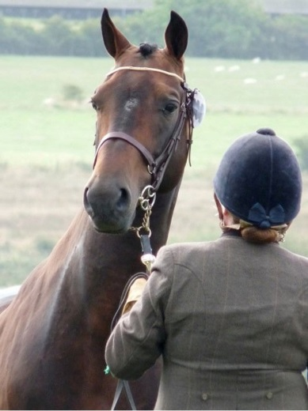
Guide to the Regional In Hand Showing Competition 2019
This is NOT a qualifier for Nationals.
- For the first year running this class we will not run separate classes for different breeds or veterans etc. All horses and ponies will be in the same class
- Each class will be separated into two sections (subject to sufficient entries): Junior section (if you are 16 or under as of 1st Jan 2019)
Senior section (if you are 17 or over as of 1st Jan 2019)
Why do in hand showing?

Showing is not only a great way of showing off your horse or pony, but it gives him/her experience of going to new places and getting used to noises and crowds if you want to take them to other competitions. It is also a great chance for you and your team to show off how well you can turn out your horse/pony - whether it is you and your family or friend, or you and your RDA groups volunteers/coach.

What do you need to do?

Firstly you need to get your horse as clean as possible, and looking as smart as possible. Some breeds keep manes and tails unplaited such as cobs and native breeds, where as other like to plait or hog manes, and plait tails. For our RDA competition we don’t mind whether you plait or don’t plait etc.

The steward will let all competitors into the ring and they will walk around the ring, keeping on the outside of the horse (if possible) so that the judge can see the horse clearly.

If you are getting too close to the horse in front of you then turn your horse into some space when safe to do so.

The steward will then ask competitors to line up in a corner of the arena whilst one horse at a time is called to do an individual trot around half the arena. This is usually done as a fast trot, and we want to be as inclusive as we can, so if you have difficulties running with your horse or pony then you may choose an RDA coach/volunteer/participant to run with your horse for you or you may ride your horse (and be led if you wish) for this part of the class. Horses being ridden may have saddles on from the beginning of the class. Horses not being ridden will be unsaddled. Riding this part of the class will not affect your score in any way for our competition. If you want a family member to run your horse for you then they must also be a RDA volunteer or on the A4 green card (ask your group or a regional officer if you are unsure about this).
Then all the competitors walk horses round the ring again and one by one the steward will call you to the middle to stand your horse still for the judge, whilst the judge asks a few questions. Then the horse is walked away from the judge, and then trotted back towards the judge. (again this can be done by your volunteer/coach/family member or you may ride it).
Once everyone has done their individual trot then all competitors will walk round the ring again until the winner is called to the middle by the steward, a and then 2nd place, then 3rd etc. We will have placing rosettes for 1st to 6th place, and then highly commended rosettes for other competitors
At the end of the class you will be encouraged to do a lap of honor around the ring in order of placing. If competitors find this too tiring they may pass their horse to a volunteer to run for them or they may walk their horse out of the ring.

How will the judge decide who is the winner?
The judge will be looking at your horse’s conformation and how well it moves, as well as its condition.
As we aren’t separating horses into different breeds or ages this year (though we may decide to do this next year if the class is popular) the judge will take into account the horse’s age when judging condition.
For our RDA class our judge will also give a score on team effort and turnout.

What should people wear?

We are not strict about this for our competition, you may choose to wear group clothing that all matches, e.g. Group polo shirts and sweatshirts and matching jodhpurs or trousers. Or you may wear jacket, shirt and tie or waist coats – don’t worry too much on colours, but if you are entering as a team e.g. you have a guide (for visually impaired competitors) or a “runner” then you will get better marks if you all match or wear clothes of a similar theme. All competitors should wear riding hats to the current safety standard, and we will be hat tagging at the beginning of the day to help you make sure your hat is up to the current standard. Ask your coach if you are unsure whether your hat has an accepted kite mark. If coaches/volunteers or family members wear hats to lead a horse then it must be up to the same standards and will be checked. RDA national also recommends that gloves are worn when leading horses.

What should the horse wear?
All the horses should wear a bridle, its usual RDA bridle is fine, or if you have a showing bridle then that is also fine. Marks won’t be deducted for not having a show bridle, though marks will be deducted if the bridle isn’t clean and well fitting. Couplings must be used if fitting a lead rein to the bit.

Horses should not wear saddles unless the competitor wants to ride the trot part of the class.
The judge may decide to ask you to take off the saddle at the end of the trot part of the class for the final walk round. Stewards can help you with this and take saddle to side of the arena safely until you leave the ring.

If your horse doesn’t like people coming up close behind him/her then please put a ribbon in his tail to warn other people from coming too close.
Horses in the ring shouldn’t wear bandages, boots or accessories such as fly fringes etc.

Conditions for our RDA Insurance
All horses/ponies must be 5 years old or over to compete and be used in RDA settings, or have passed an assessment by Anne Furey prior to competition.
All participants must wear riding hats when leading horses (hats must be to current standard).
All family members or friends accompanying participants into the ring must also be RDA volunteers or have signed the A4 Green card for their RDA group.

